2-2 Assignment: Merging Data with Python

DAT-430

Ashley Littles

Southern New Hampshire University

Python is an extremely popular tool companies utilize for analyzing their data. Python is very user friendly to new data analysts when working on cleaning and merging data. This blog post will demonstrate how we can use Python to merge two sets of data. The two data sets that will be used are the files Sentiment_Feb2014.csv and Sentiment_March2014.csv. The two data sets will be cleaned and merged with the use of Python.

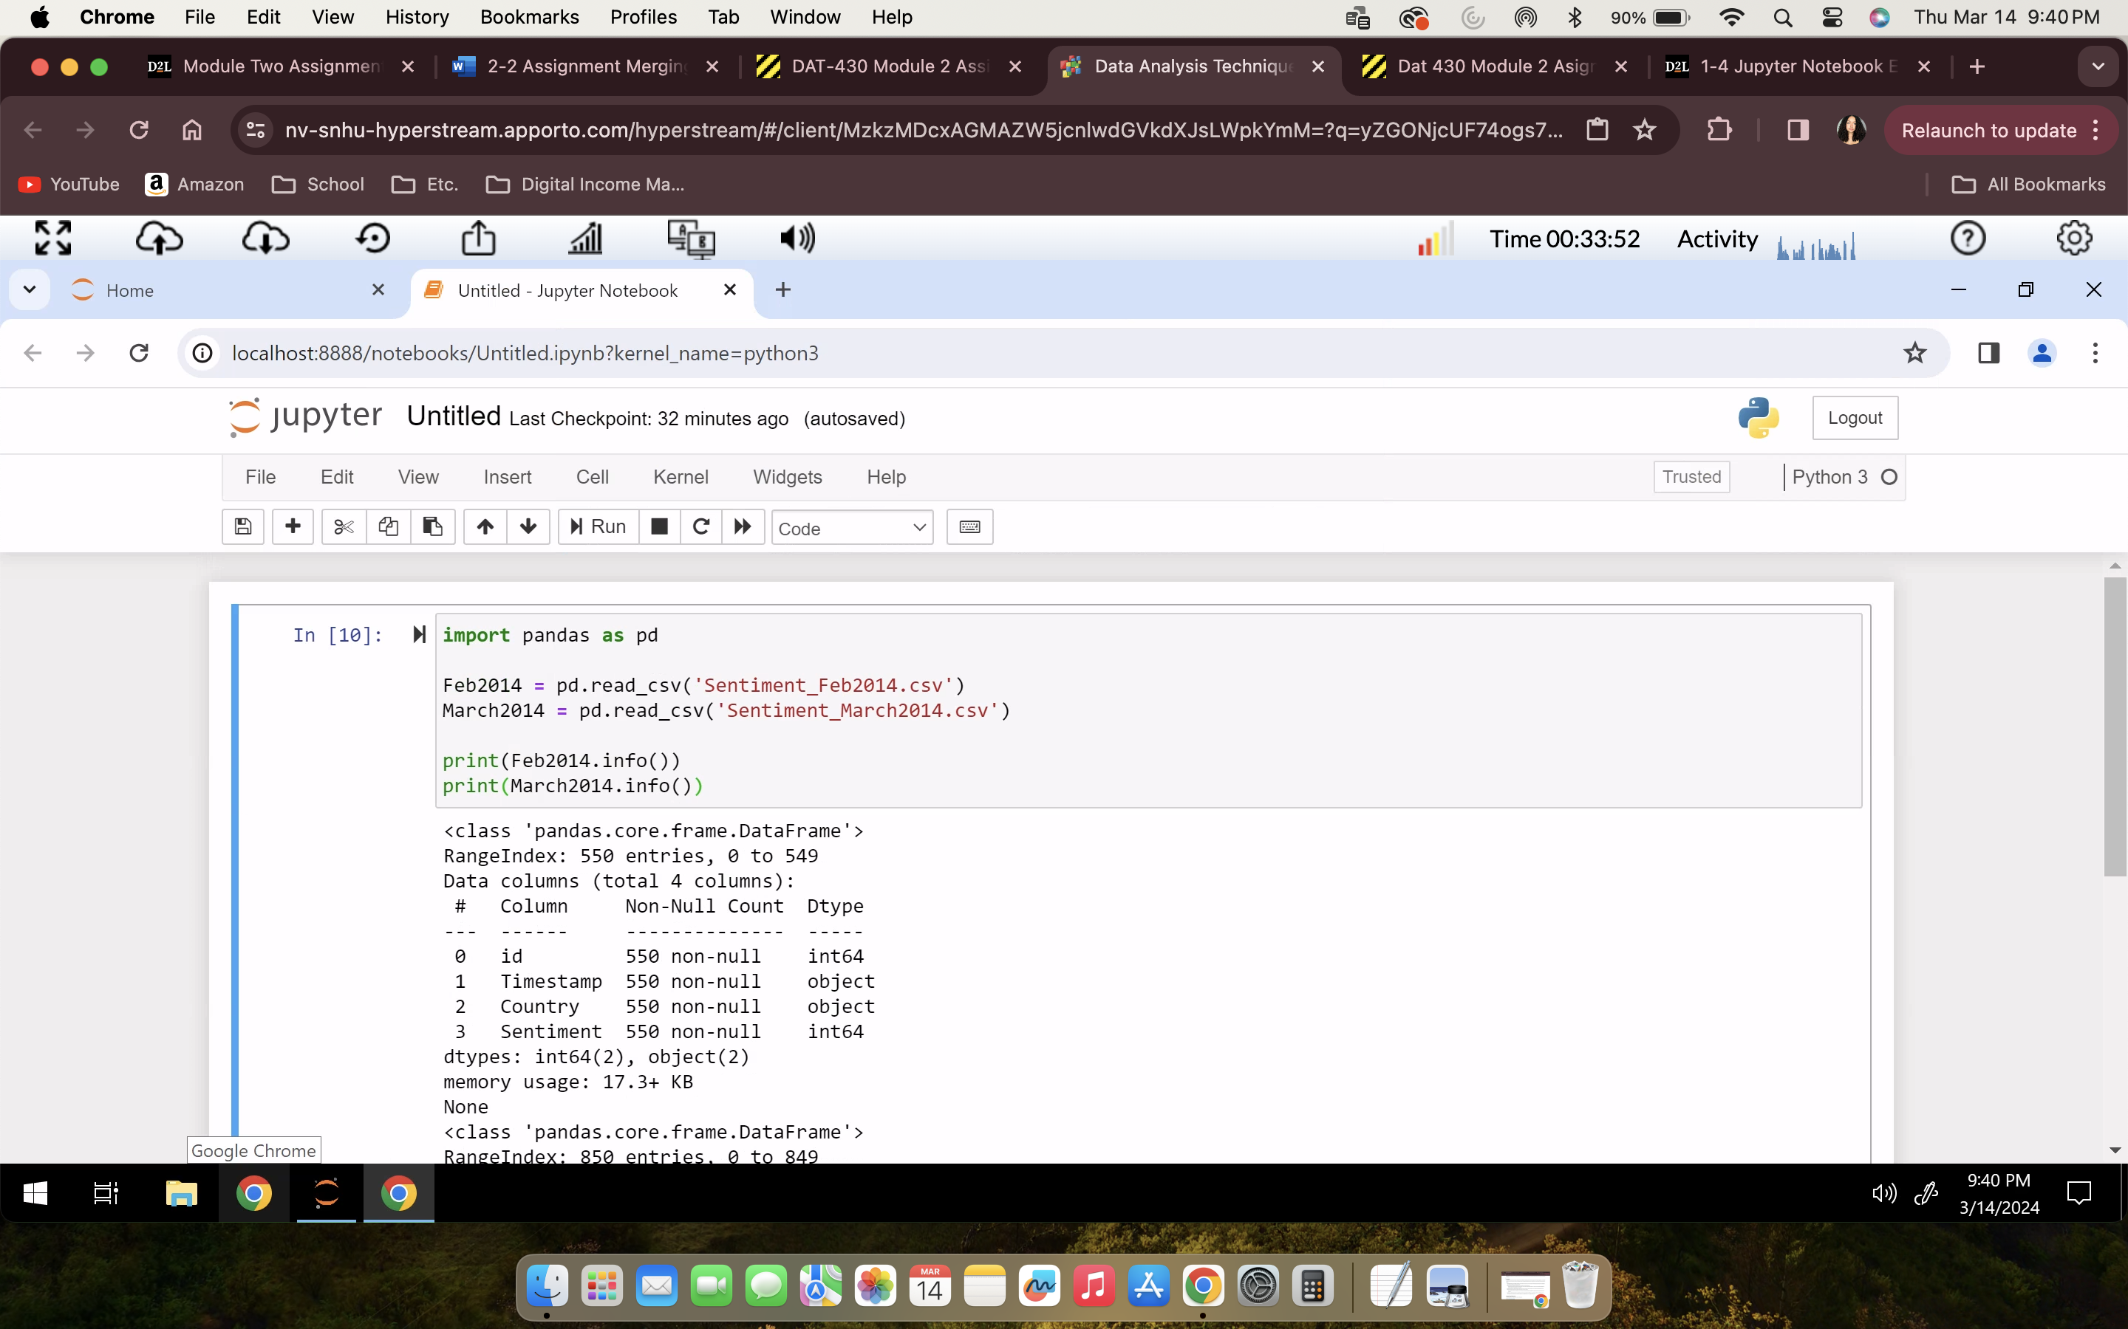

The first step in cleaning the data is importing our files within the pandas library. To do this we would insert the code above.

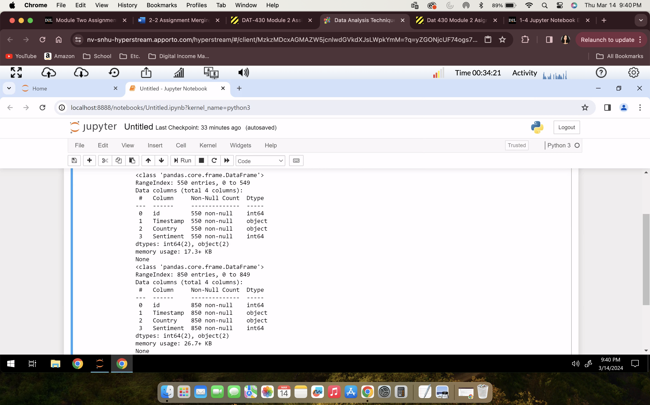

After writing the code for importing the files we will receive this output showing the data columns in the picture above.

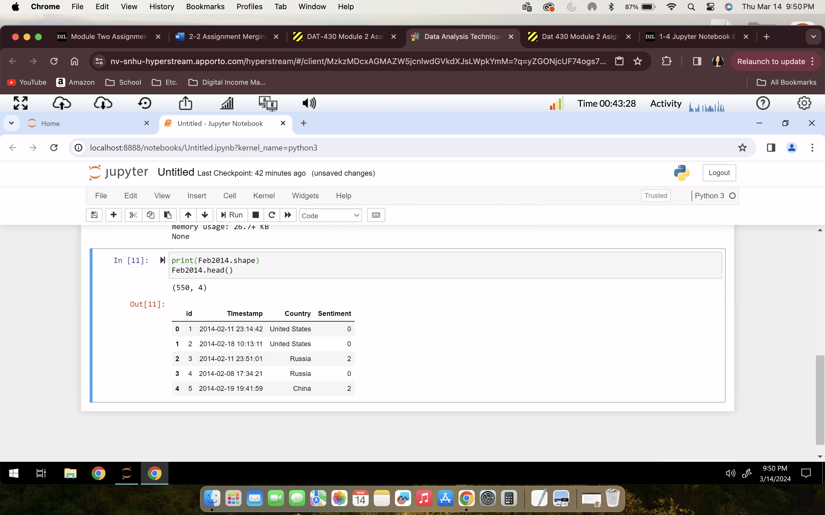

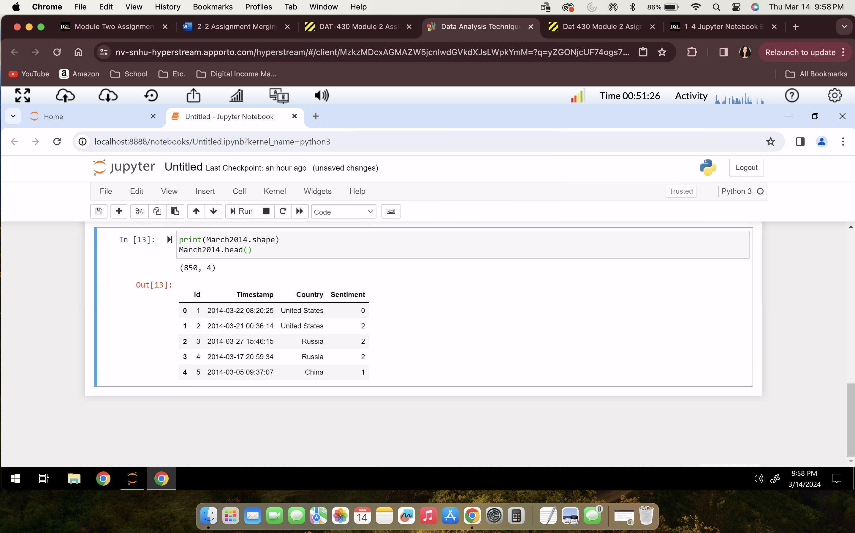

Next using the df.head and df.shape functions we get the outputs of the first 5 rows from both the Sentiment_Feb2014 and Sentiment_March2014 data sets. Only displaying 5 rows from each data set makes the data analyzing and cleaning process a lot easier. This allows us to check over the data before proceeding to merge it. You want to check for any errors or inconsistencies with the data as well as the overall accuracy of the data sets. Once you have thoroughly checked over and cleansed the data sets you can move on to the next step of merging the data sets.

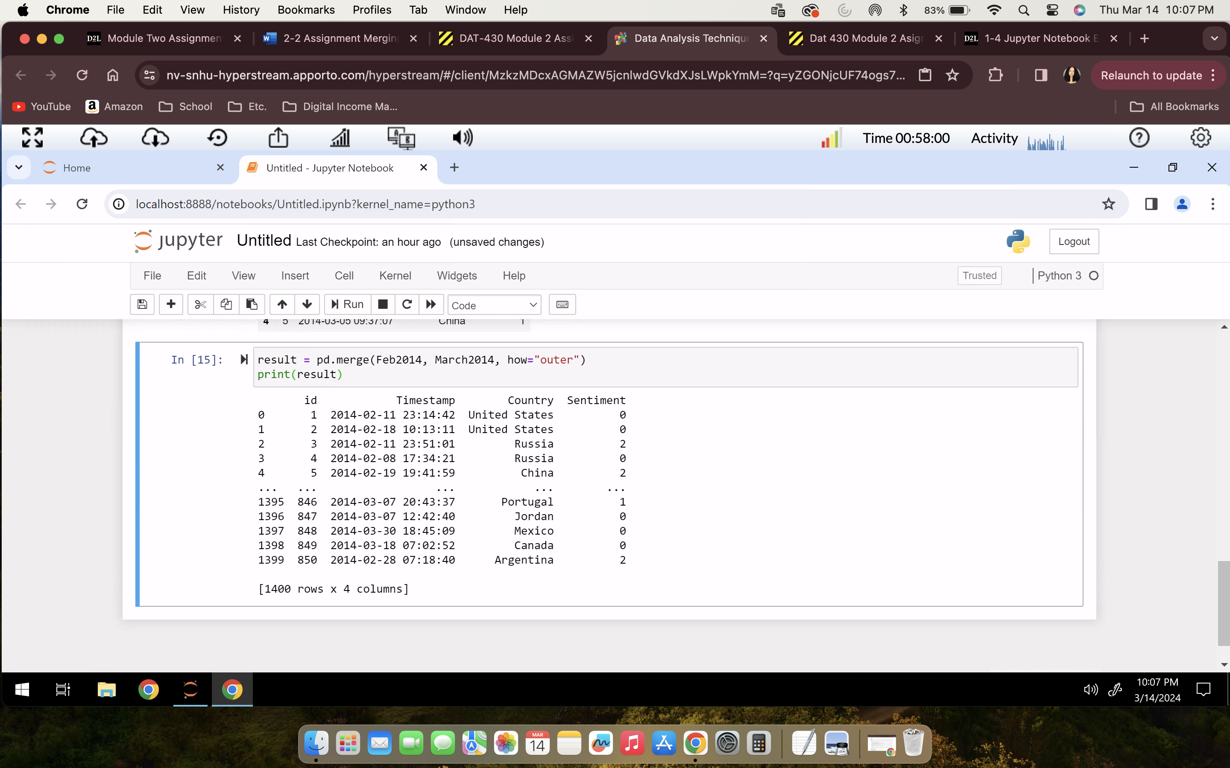

To proceed with merging in Python you start by using the pd.merge() function shown above. This function will create a new DataFrame that will ultimately combine the information from the two inputs. The specific type of merge we performed is the outer merge. The outer merge allows for the combination of keys from each frame preventing data loss.

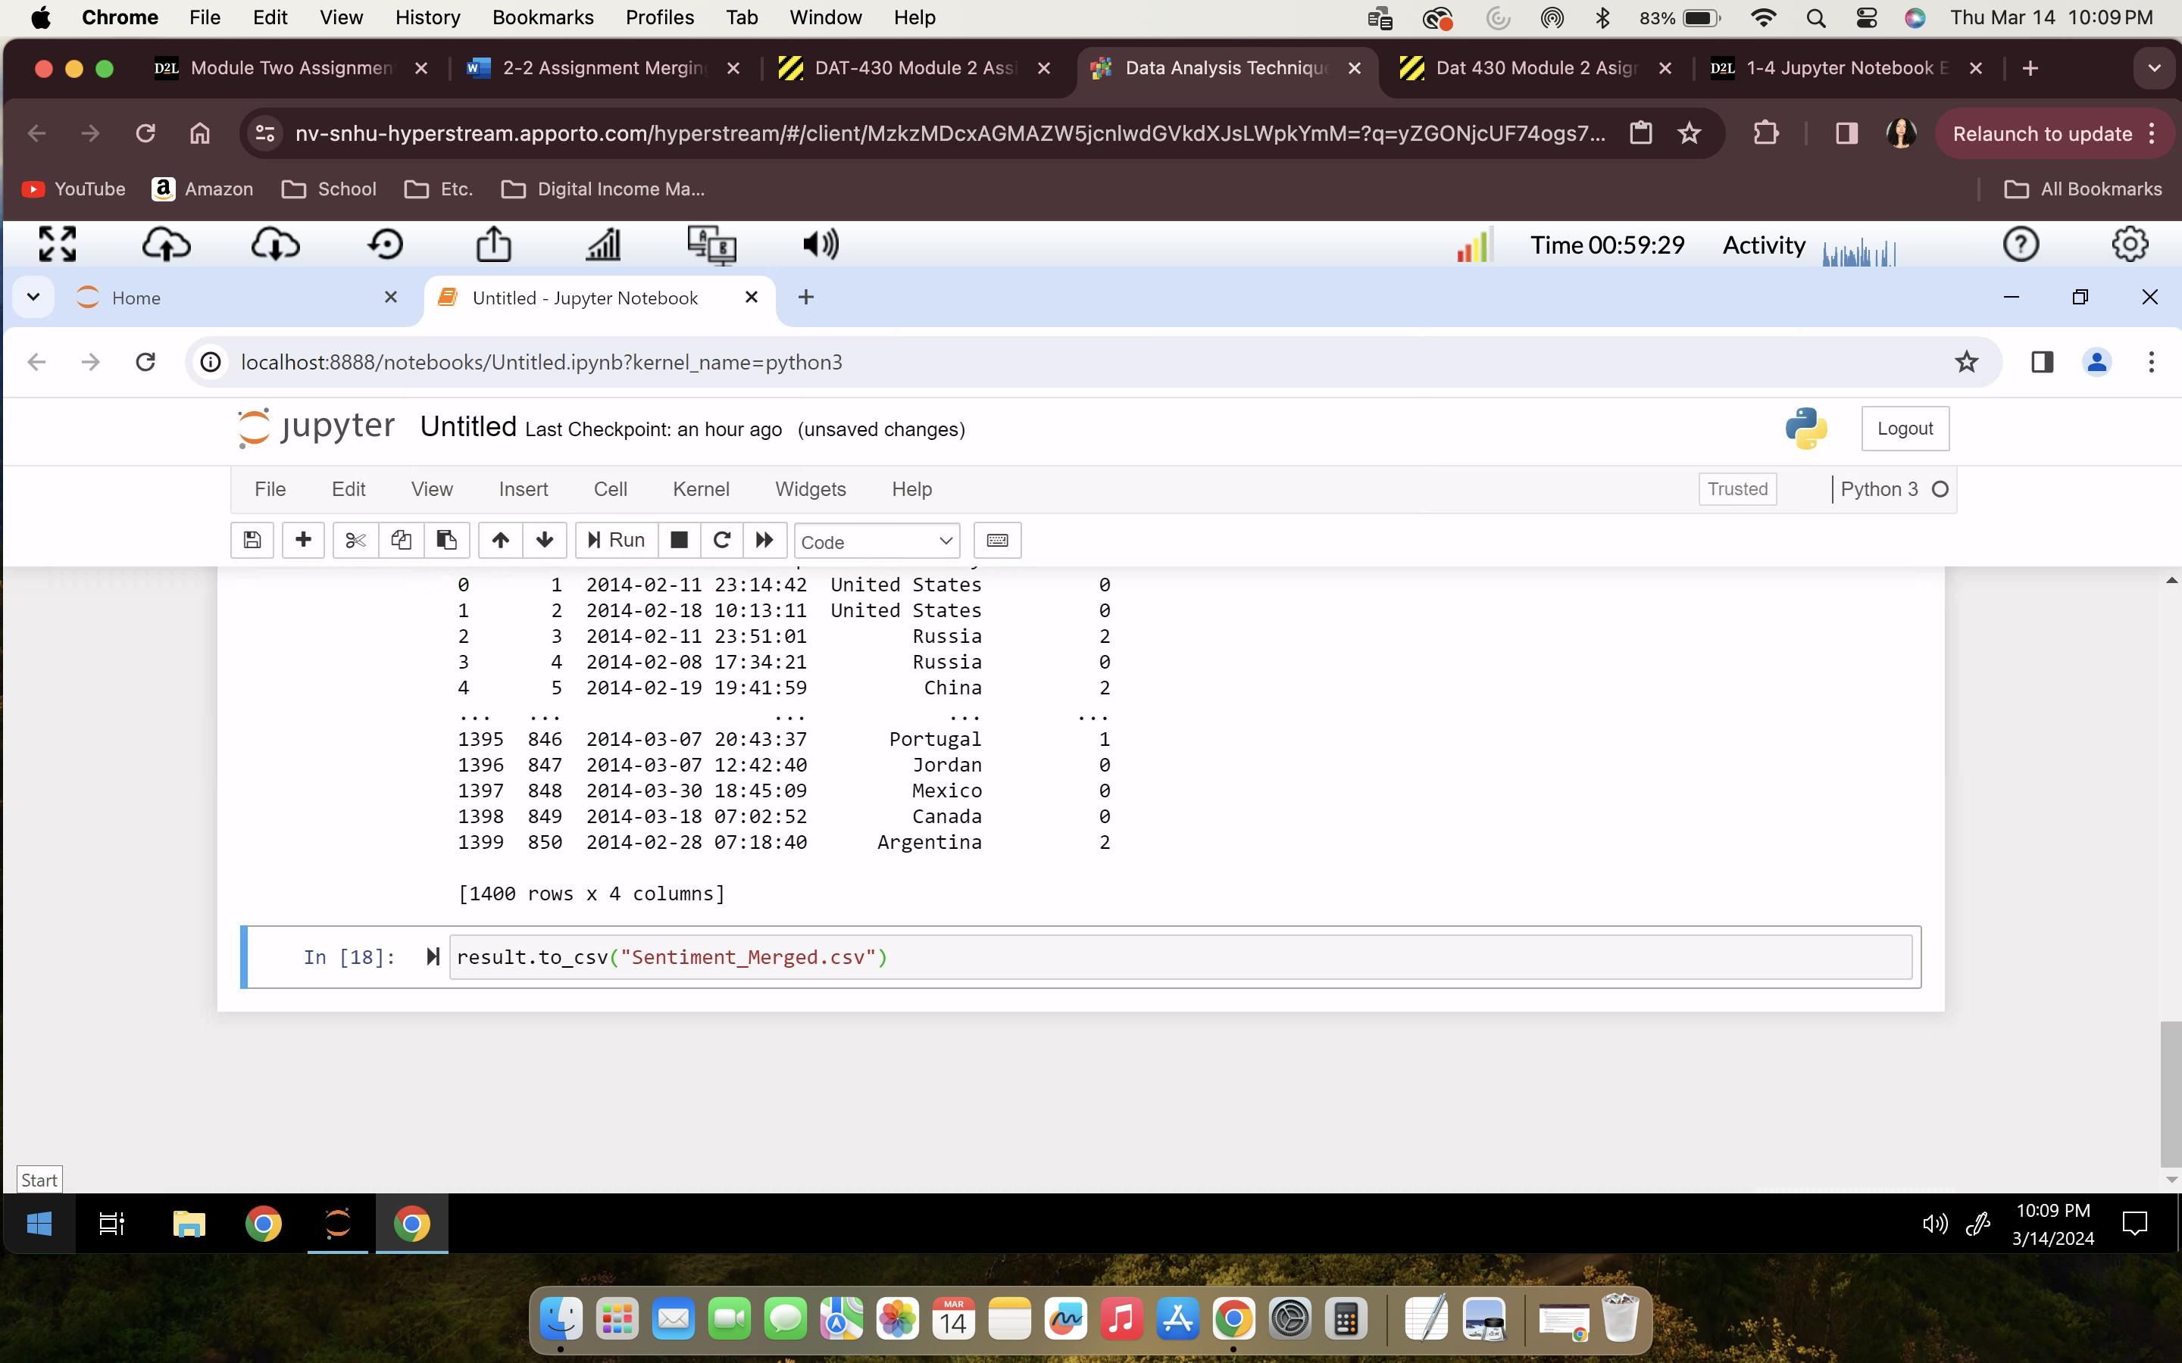

After successfully merging the data, we can proceed with exporting the newly cleaned and merged data. To do this we will use the result.to_csv() function to export as Sentiment_Merged.csv since now the Sentiment_Feb2014.csv and Sentiment_March2014.csv data sets are combined into one data set.

References

VanderPlas, J. (n.d.) *“Combining Datasets: Merge and Join”* Python Data Science Handbook <https://jakevdp.github.io/PythonDataScienceHandbook/03.07-merge-and-join.html#:~:text=merge()%20function%20recognizes%20that,information%20from%20the%20two%20inputs>.

Pandas (n.d.) *“pandas.DataFrame.merge”* <https://pandas.pydata.org/docs/reference/api/pandas.DataFrame.merge.html>